Our vision for residential child care
Reclaiming Social Work in Aberdeen
4 : Residential child care

Reclaiming Social Work in Aberdeen
2 : Social Work Units

Reclaiming Social Work in Aberdeen
2 : Social Work Units

Reclaiming Social Work in Aberdeen
2 : Social Work Units
Our vision for residential child care is that children and young people feel safe, healthy, are achieving, nurtured, active, respected and included. Our mission is that every young person looked after and accommodated achieves their full potential. Within the last 6 months our residential child care services have been strategically reviewed to ensure that we have a residential model which is fit for purpose for the future, providing:
- high quality provision and improved outcomes for children and young people who are looked after away from home
- a commitment to continuous improvement and best value
- residential placements in Aberdeen which meet the assessed needs of children and young people who are looked after away from home

Reclaiming Social Work and Residential child care
Reclaiming Social Work in Aberdeen
4 : Residential child care

Reclaiming Social Work in Aberdeen
2 : Social Work Units

Reclaiming Social Work in Aberdeen
2 : Social Work Units

Reclaiming Social Work in Aberdeen
2 : Social Work Units
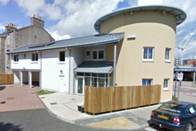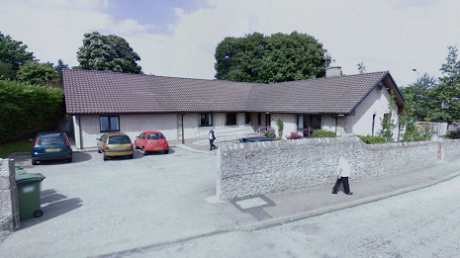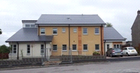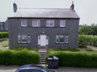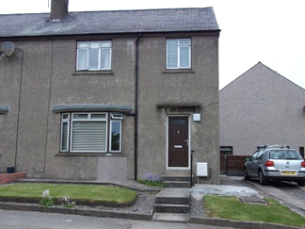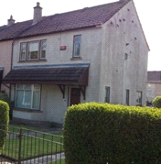Our aim is that with the introduction of Reclaiming Social Work we will:

- have fewer young people who are looked after in out of authority placements
- enable young people to access local provision which can support their recovery and reunification, where appropriate
- work with CELCIS and seek guidance and consultation on improving practice in residential child care based on evidential approaches; and
- create good systems which support the identification of evidence that our practice is making a positive difference.
In addition:
- Residential staff are included within the training for the Systemic Family Therapy Advanced Certificate
- the main principles and approaches of systemic work with families and young people will be developed across the residential workforce
- Reclaiming Social Work is influencing the organising principles within our Children’s Homes
- The residential childcare workforce will have equity of access to developing their skills and knowledge of systemic practice and related approaches which seek to reach collaborative solutions with young people and their families

Our review of residential child care
What we have agreed.
- Emergency and unplanned admissions create pressures within our Homes.
- When young people require to be accommodated they should be in resources local to their homes and communities.
- Our responses to challenging behaviour and need will be well informed and staff will be confident and supported in their roles.
- We will consolidate our provision within three key themes in terms of how care is offered, ie. mainstream; single gender and throughcare.
- We will reduce the number of buildings in the service and concentrate on improving quality within this capacity.
- By working closely with our Alternative Family Care service we will work to place young people appropriately and reduce the number directly accommodated in our Children’s Homes.
- We will continue to work closely with Inclusion services and ensure that the educational needs of looked after children and young people are met.
- Build on and improve from Care Inspection reports and sustain and exceed previous inspections.
Upskilling the workforce

The Review of Residential Childcare has identified a revised staffing structure for each Home which will continue to meet and exceed SSSC requirements for our workforce. Staffing capacity will be enhanced and better reflect the level of care needed to ensure a safe and nurturing environment.
There is an ongoing review of our recruitment to residential child care strategy and this will be informed by an evidential process which better considers the skills and personal attributes which we value and need to see reflected within the workforce. Our amended recruitment procedure is being supported by a specific induction & CPD programme.
Reclaiming Social Work in Aberdeen
For more information about Reclaiming Social Work in Aberdeen or about jobs in Children’s Social Work in the city please contact us by e-mail: together@aberdeencity.gov.uk or by phone on 01224 522533 or at our website http://www.aberdeencity.gov.uk/jobs_careers/jobs_and_careers.asp

